Welcome to biochemistry
Sayfeddin saad

Basics of Chemistry
A. The Atom
1. Smallest unite of any element
2. Made of a positive nucleus surrounded by a cloud of negative particles called electrons.
3. All elements are listed on the periodic table.
4. Elements in the body:
Oxygen (65%), Carbon (18%), Hydrogen (10%), Nitrogen (3%), Calcium (1.5%), Phosphorus (1.0%), Potassium (0.35%), Sulfur (0.25%), Sodium (0.15%), Magnesium (0.05%),
Copper, Zinc, Selenium, Molybdenum, Fluorine, Chlorine, Iodine, Manganese, Cobalt, Iron (0.70%)
Lithium, Strontium, Aluminum, Silicon, Lead, Vanadium, Arsenic, Bromine (trace amounts)
B. Molecules
1. When two or more atoms join together, they form a molecule.
2. These are called chemical bonds, and are based on interactions between the electrons.
3. If a bond joins different elements, the new substance is a compounds.
C. Types of Bonds
1. Ionic bonds.  a. Electrons move from one atom to the other.  b. Atoms become positively or negatively charged; called ions.  c. Charges attract or repel.  d. Good for conducting electricity. | 2. Covalent bonds.  a. Electrons are shared between two atoms.  b. Atoms must remain together  c. Bonds are flexible  d. Good for large structure. | 3. Hydrogen bonds.  a. Hydrogen holds electrons weakly  b. Has a slightly positive charge, attracted to anything negative.  c. Creates weak bonds that help hold structures but can be broken easily.  d. Examples: DNA

Solution, solvent, and solute
Solute and Solvent are the part of the solution where the dissolved matter in any solution or mixture is called as the solute, while the liquid or gas that dissolves another liquid, solid or gas is called as the solvent.
The homogenous mixture is the solution in which the solutes dissolve completely and uniformly into the solution. While solubility is the ability of the substance to dissolve into another substance.
According to the basis of physical component solutions are of the following types:
(i) Solid solution
(ii) liquid solution
(iii) Gaseous solution
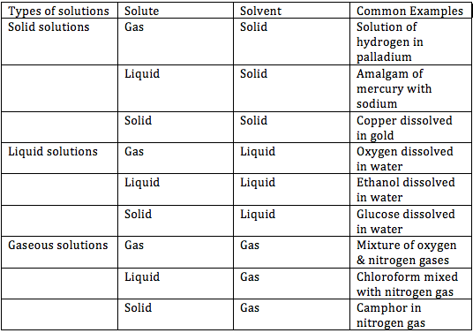

Sayfeddin saad
Welcome to biochemistry
Sayfaddon.saad@ishik.edu.iq

